TFB Legacies Consulting
Splitwise App as Loan Tracker



This document summarizes how to use the Splitwise app for tracking the loan repayment process. It details how to use the expense splitting and tracking app for loans and interest.
Disclaimer: TFB Legacies Consulting shares learning and advice about Family Bank principles and practices. Nothing in this document should be considered as legal, tax, or financial advice. Please consult the respective professionals for legal, tax, or financial products and services.



© 2025 by TFB Legacies Consulting https://www.family-legacies-consulting.com/

Licensed under CC BY-NC 4.0

Split expenses with friends. :: Splitwise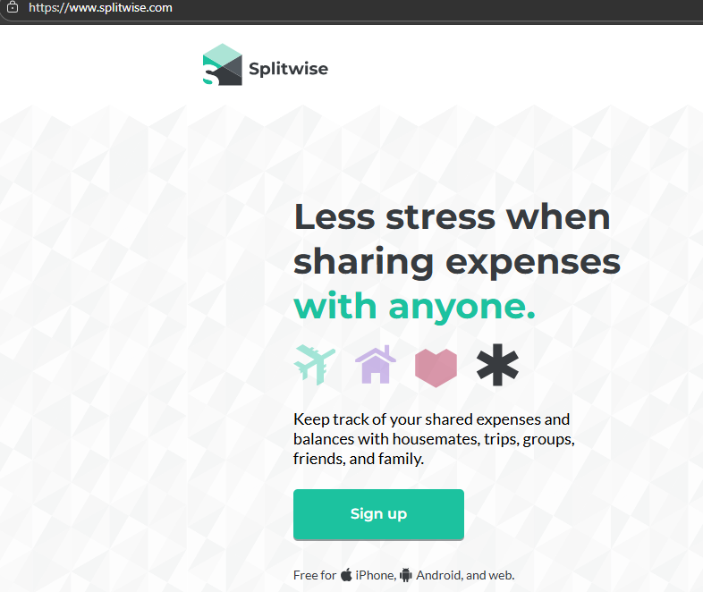

Splitwise is a free, user-friendly app designed to simplify tracking shared expenses, making it ideal for families to monitor loans and manage who owes what with ease and transparency.

What is Splitwise?
Splitwise is an expense-sharing platform available on Android, iPhone, and web that helps friends, roommates, or family members track shared costs, debts, and repayments. It organizes expenses into groups, calculates each person's share, keeps running balances, and provides options to settle debts through cash or linked payment apps like Venmo or PayPal. It minimizes awkward conversations about money by showing clear records of who owes whom and how much

How does Splitwise get paid?
Splitwise’s business model combines:
- A free app with basic expense tracking and group management
- A paid subscription (Splitwise Pro–currently $3/mo) for enhanced features and better user experience. This includes an automated recurring payments feature.
- Advertising revenue in the free tier
- Interchange fees from its debit card product
- Opportunities through partnerships and financial integrations
Splitwise does not charge a fee for Venmo or Paypal within the app.
Splitwise can track bank transfers as manual “cash payments”, but there is no facility to do so within the app itself. Splitwise does not engage with banks directly
.
Benefits of Using Splitwise for Family Loans
- Transparency: Everyone in the family can see the loan balances clearly, reducing misunderstandings.
- Convenience and Organization: Keeps a digital record that’s accessible from any device.
- Flexibility: You can manage loans that are repaid over time or shared recurring expenses (like utilities).
- No Fee for Basic Usage: Splitwise is free to use, only charging for premium features; payment transactions via PayPal or Venmo may have third-party fees. Bank transfer capabilities are also available as part of the premium features.

Setting Up Splitwise for Family Loan Management
- Download the app and create an account.
Download and install the Splitwise app, create an account.

- Create a group for each loan:
Since Splitwise allows everyone in a group to see the status of expenses and payments, if you want a loan and payments to be private, set up a separate group for each loan. The Lender and the Borrower are invited to a new Splitwise group designed specifically for “shared expenses”. This centralizes all transactions in one place, and only those in the group can see the details.

- Adding and Tracking Loans:
We recommend a new group for each loan, so that only members of that group see the loans and payments. Treat loans as “expenses” within the group. When one family member loans money to another, enter it as an expense with the Lender as the person who paid the “expense” and the Borrower as the person who owes. Use the description and note to specify that it’s a loan.

- Interest “Expense”: For the interest amount, you enter that expense as a separate line item, indicating how much interest is being charged and for what period in the description If additional periods are required because a loan repayment is extended, you can add more expense line items to an open loan as needed later.

- Splitting Expenses and Loans:
Splitwise allows you to split expenses equally, by percentages, shares, or itemized amounts, giving you flexibility to reflect uneven loan amounts or complex repayment arrangements typical in family finances. For loans from the Family Bank, you would typically add an expense, title it as a Loan, and then reset the “share” from the default of 50% to 100% paid by the borrower.

- Recording Repayments (Settling Up):
Family members can record repayments using the “Settle Up” feature by either logging cash payments or using integrated payment options like PayPal and Venmo where available. This updates the balances instantly and keeps the loan tracking accurate. If you want to set up recurring automatic payments, this can be done by signing up for the Splitwise Pro features, (currently $3/mo). Bank Transfers are available as a new feature of the Splitwise Payments premium program.

